
Electric Rice Cooker
60 Cup (30 Cup Raw)

Model: SRC-60H
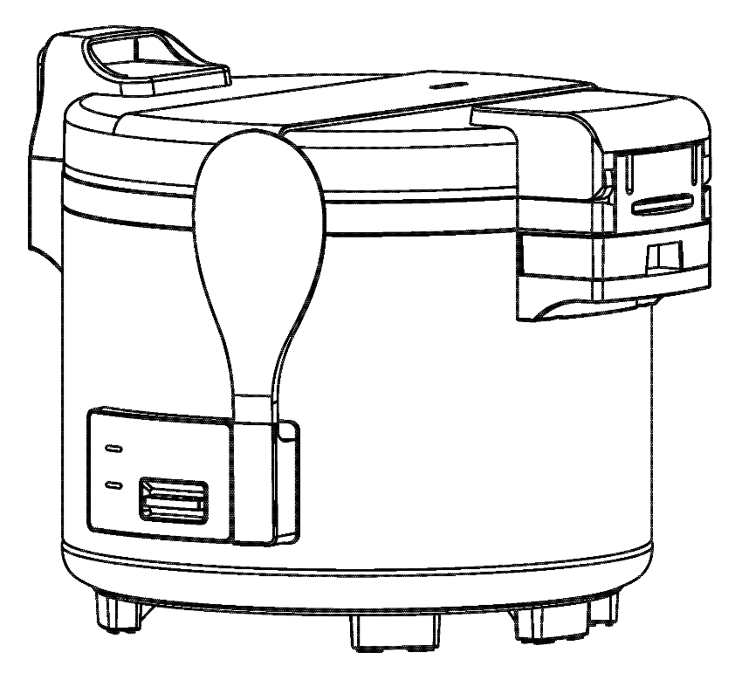

Please read and keep these instructions for future reference. Indoor use only.
NOTE: Retain these instructions for future reference.

THANK YOU
FOR YOUR PURCHASE

Table of Contents
Safety Precautions 1
Specifications 2
Precautions 3
Parts Identification 4
How To Cook Rice 5
How To Keep Cooked Rice Warm and Tasty 6
How To Use Steamer 6
Maintenance 7
How To Clean 7
Features 8
Diagram 8
Troubleshooting 9
The exploded view 10
Parts List 11
Warranty Service Information 12

Safety Precautions

- Read all instructions carefully before using the appliance for the first time.
- Do not use outdoors: commercial and indoor use only.
- Do not immerse in water.
- CAUTION: HOT SURFACE.
- CAUTION: Risk of fire or burn hazard. Do not store near combustible material.
- CAUTION: To reduce the risk of electric shock, cook only in the removable container.
- CAUTION: Risk of fire or electric shock. Only operate this appliance with the removable container in place.
- To reduce the risk of electric shock, do not remove or open the bottom cover. There are no user-serviceable parts inside. Leave servicing to qualified technicians.
- The rice cooker should be stored and operated away from high temperatures.
- Do not block the steam vent on the top of the lid.
- Before plugging in the power cord, ensure that the outlet's voltage rating is compatible with the equipment.
- Do not insert the plug into the socket without placing the pot in the rice cooker.
- Do not heat the cooking pan on any other stove.
- Make sure the cover is properly locked when cooking.
- Do not use abrasive sponges or scrubbers that could scratch surface.
- Damage to the power cable should be repaired by a certified technician.
- Keep out of reach of children.
- This product is not designed for use by individuals with certain limitations, including children.

Specifications

Model | Power  (W) | Voltage  V/Hz/ph | Capacity | Exterior Dimensions | Gross  Weight
SRC-60H | 1550 | 120/60/1 | 60 cups  / 30 cups raw | 18 7/8 x 15 7/8 x 14 5/8 | 20
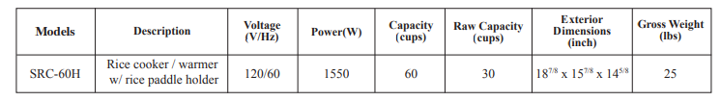

Precautions
1. The rice cooker will not function if the pan is not placed inside the cooker.
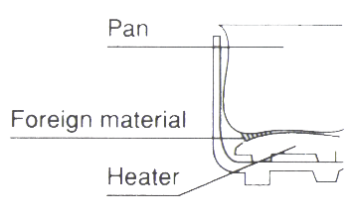
2. Always keep the bottom of the pan and the heater clean and dry. Any foreign material between these two components will cause the cooker to malfunction.
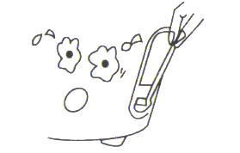
3. Do not force the switch if it cannot be pressed to the cooking position. The switch will typically remain in the off position if the pan is not placed in the cooker or immediately after cooking has completed.
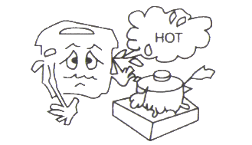
4. The rice cooker should be placed on a stable surface. Avoid exposure to water, high humidity, or direct heat.
5. Do not cover the outer lid with anything while the rice cooker is in use.
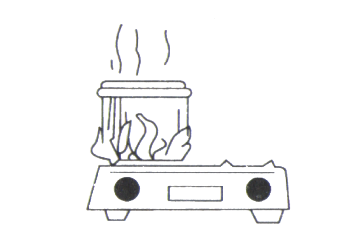
6. Do not use the pan directly on an open fire.

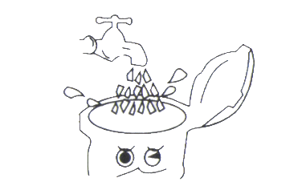
7. Do not immerse the cooker in water and avoid putting it near a fire.

Parts Identification
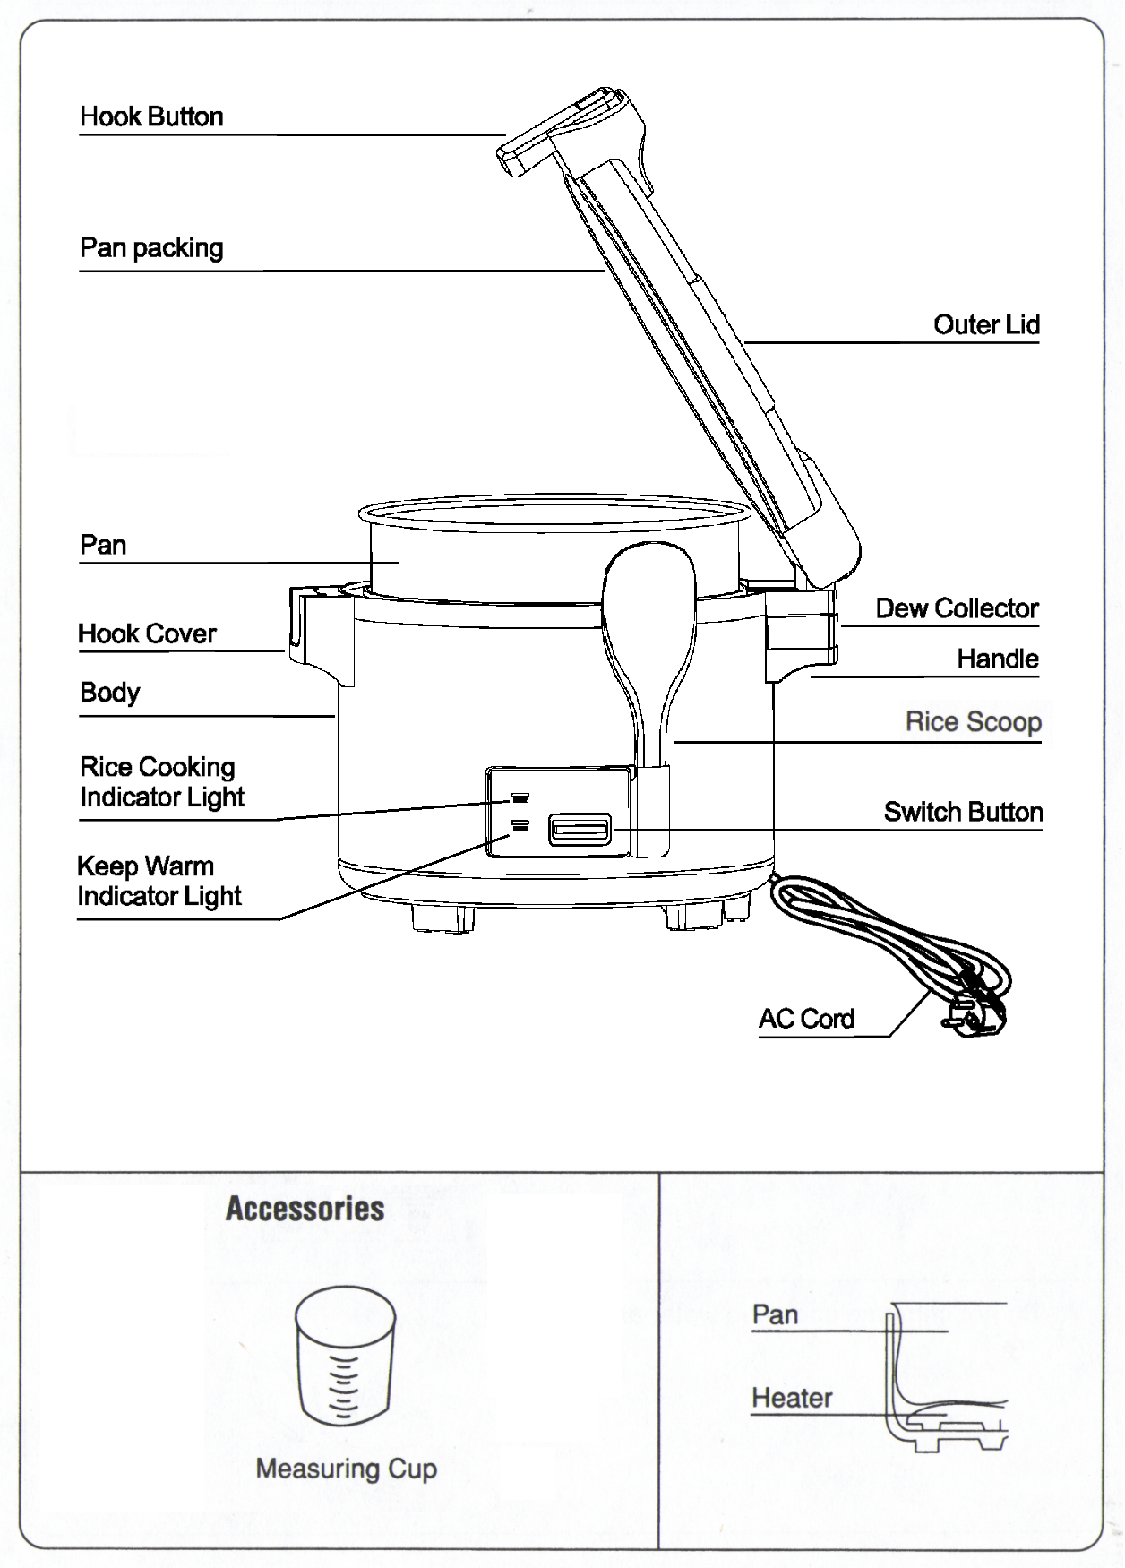

How To Cook Rice
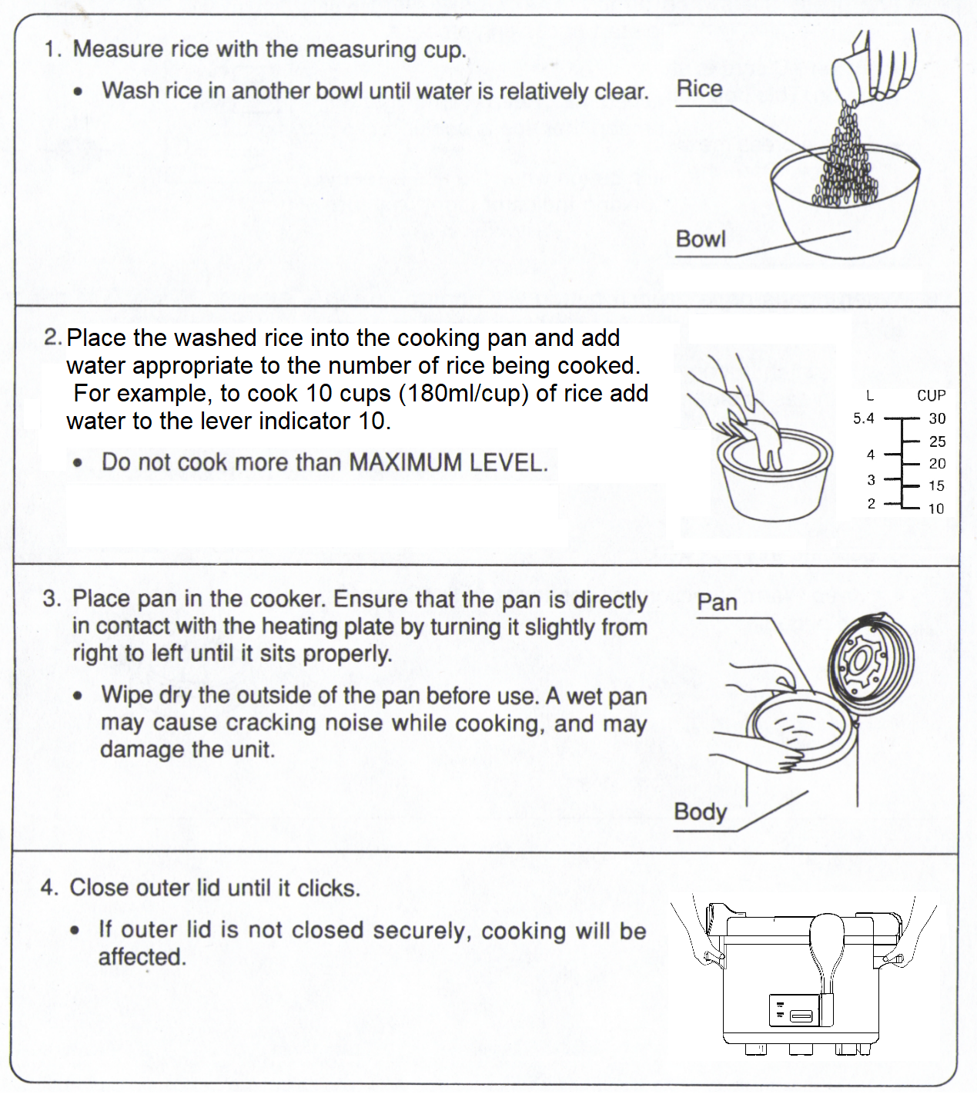
How To Load And Unload Dew Collector
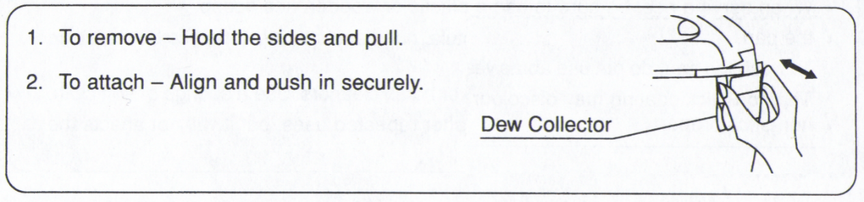

How To Keep Cooked Rice Warm and Tasty

Washing rice
Bran may give an unpleasant odor to cooked rice. Wash rice thoroughly to effectively remove the bran.

Keep warm function
Keeping cooked rice warm or using the 'Keep Warm' function for more than 5 hours may cause discoloration or an unpleasant odor. For the best taste, it is recommended to serve the rice as soon as possible.
When using the 'Keep Warm' function, ensure that the pan contains at least 4 to 6 bowls of cooked rice.

Inner lid
Be careful not to deform the inner lid and avoid rough handling. Deformation of the inner lid can negatively impact both cooking performance and the 'Keep Warm' function.

How To Use Steamer

1. Steamer Placement
Note: The steamer must be purchased separately
Place the steamer on top of the rice cooker’s pan. Then, add the prepared food to the steamer.

2. ADD WATER
The water level should not be higher than the bottom of steamer.

3.STEAMING TIME
The duration of steaming will vary depending on the steam temperature, the amount of water, and the voltage of the power source. Steaming time can be extended by adding more water

4.STEAMING ABILITIES
Can be used to steam bread, vegetables, and meats such as chicken and fish.

Maintenance
1. Unplug the plug from the wall socket before cleaning. Wait until the unit is cool to clean.
2. Clean the outside of the rice cooker with a damp cloth, then wipe it down with a dry cloth.
3. Clean the inner pan with a rubber or foam sponge. Do not use a rough cleaning tool as it will damage the nonstick coating.
4. Unplug the water reservoir and dispose of the water inside.
5. Clean the heater components with a damp cloth, then wipe it down with a dry cloth.

How To Clean

After cooking is complete, unplug the power cord. Once the unit has cooled, clean the body and parts of the cooker as follows:
- Use a clean cloth to wipe the body of cooker.
- Remove the pan and inner lid from the cooker, clean them with dish soap, rinse thoroughly, and dry with a soft cloth.
- Wipe the outside of the body and outer lid with a clean, damp cloth. Do not use abrasive or harsh cleaners on any part of the cooker. Avoid immersing any part of the cooker in water or other liquids, except for the pan, steamer plate, inner lid, and dew collector.
- Grains of rice or other foreign materials may stick to the heating plate. These should be removed to ensure proper cooking. To clean the heating plate, you can use soft steel wool. Then, smooth and polish the area to ensure good contact between the heating plate and the bottom of the pan.
- Improper cleaning of the rice cooker may cause unpleasant odors.
- Any residue of vinegar or salt may cause the pan coating to corrode.

Features
- The simple push-button ON/OFF control switch ensures easy operation.
- Once the rice is cooked, the rice cooker automatically switches to the warm function.
- Using the measuring cup included with this cooker, 6 cups of uncooked rice can yield 60 bowls of cooked rice.

Diagram
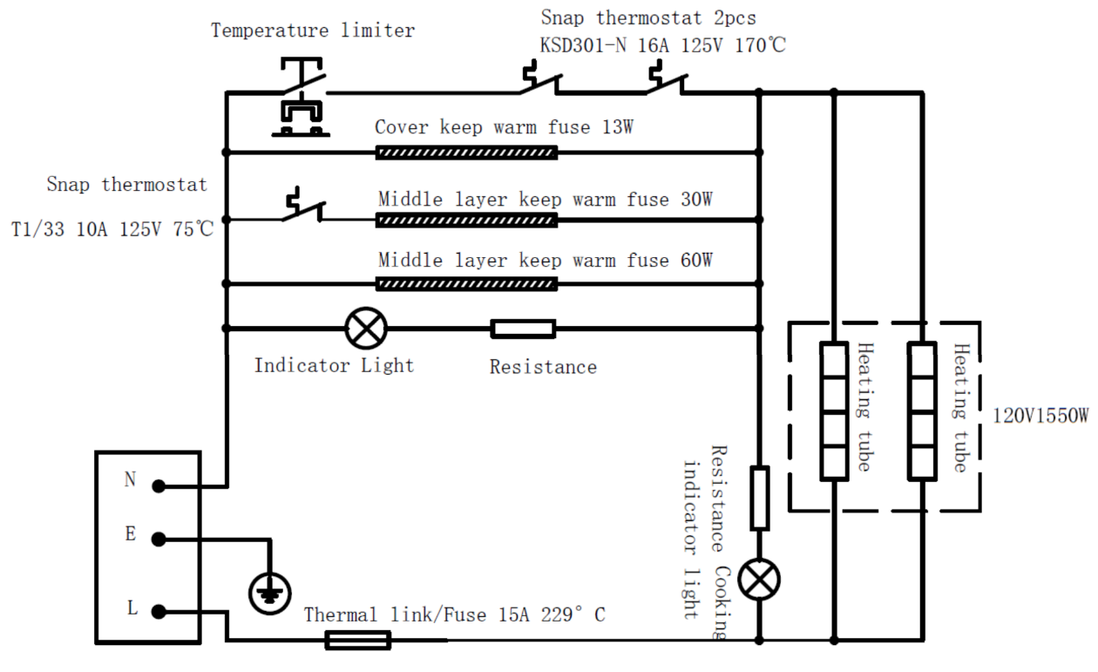

Troubleshooting
Issue | Solution
Rice is not fully cooked | Adjust the ratio according to the instructions on the rice packaging or recipe.
Rice is not fully cooked | Turn off and unplug the unit, allow it to cool completely, and then remove any rice pieces with a dry cloth.
Rice is not fully cooked | Replace the inner tank or heating plate.
Rice is not fully cooked | Ensure the top cover is properly secured.
Rice is not fully cooked | Press the "Cook" button again.
Unit does not turn on | Check and ensure that the outlet is properly wired to meet the electrical specifications of this unit
Rice is overcooked | After the rice is cooked and has entered the "Keep Warm" stage, do not press the "Cook" button again.
Rice is overcooked | Turn off and unplug the unit, allow it to cool completely, and then use a dry cloth to remove any rice pieces.
Air leaks from the lid during cooking | Ensure the top cover is properly secured.
Air leaks from the lid during cooking | Replace the inner pan
Non-functional upon arrival | Try plugging the unit into multiple outlets. If the issue persists, please contact customer service.
The unit powers on but does not heat up | Ensure that the outer bottom of the pot and the inner plate of the drum are clean. These areas must be free of any liquid, dirt, or rice to ensure optimal performance.
The unit quickly switches from cooking to warming without completing the cooking process | If the unit switches from cooking to warming immediately or after a few minutes, ensure that you are not overusing it. The unit must have enough time to cool down completely before starting another cooking cycle.
 | Ensure that both the outer bottom of the pot and the inner plate of the drum are clean.
Rice is not cooking | Ensure the rice cooking indicator light is on, not the rice warming indicator.
Rice is not cooking | Wash and soak the rice for at least 15 minutes before cooking. For best results, soak for 30-60 minutes.
Rice is not cooking | After switching from cooking to warming mode, let the rice stand in the cooker with the lid on for 15 minutes before serving.

